**PROJECT REPORT**

**1. INTRODUCTION:**

# 1.1 Project Overview

* This project is based on Internet Of Things (IoT), that can measure soil moisture, Humidity and temperature conditions for agriculture and crop protection using Watson IoT services. IoT is network that connects physical objects or things embedded with electronics, software and sensors through network connectivity that collects and transfers data using cloud for communication. Data is transferred through internet without human to human or human to computer interaction.
* In this project we have not used any hardware. Instead of real soil moisture, Humidity and Temperature data obtained from sensors we make use of IBM IoT Simulator which can transmit these parameters as required.

# 2.2 Purpose

* An intelligent crop protection system helps the farmers in protecting the crop from the animals and birds which destroy the crop.
* This system also helps farmers to monitor the soil moisture levels in the field and also the temperature and humidity values near the field. The motors and sprinklers in the field can be controlled using the mobile application.

**2. LITERATURE SURVEY:**

# 2.1 Existing Problem

* Agriculture is a field which forms the basis of our economy. Yet it faces a lot of problems in terms of availability of resources, Irrigation, increasing rate of Pesticides, Climatic disasters, Insects which ruin the crops and makes a huge loss in this sector.
* In agriculture water is needed for the crops for their growth. If the Soil gets dry it is necessary to supply water. But sometime if the farmer doesn't visit the field it is not possible to know the condition of soil.
* Sometimes over supply of water or less supply of water affects the growth of crops.
* Sometimes if the weather/temperature changes suddenly it is necessary to take certain actions.
* Specific crops grow better in specific conditions, they may get damaged due to bad weather.

# 2.2 References

* https://smartinternz.com/assets/docs/Smart%20Home%

20Automation%20using%20IBM%20cloud%20Service s%20(1).pdf

* https://smartinternz.com/assets/docs/Smart%20Home%

20Automation%20using%20IBM%20cloud%20Service s%20(1).pdf

* https://openweathermap.org/
* https://smartinternz.com/assets/docs/Sending%2

0Http%

20request%20to%20Open%20weather%20map%20 web site%20to%20get%20the%20weather%20forecast.p df

* https:/[/www.youtube.com/watch?v=cicTw4SEdxk](http://www.youtube.com/watch?v=cicTw4SEdxk)
* https://smartinternz.com/assets/docs/Smart%20Home%
* 20Automation%20using%20IBM%20cloud%20Service s%20(1).pdf
* https://github.com/rachuriharish23/ibmsubscribe

# 2.3 Problem Statement Definition

* Smart Crop Protection System based on IoT can monitor soil moisture and climatic conditions to grow and yield a good crop.
* The farmer can also get the real-time weather forecasting data by using external platforms like Open Weather API.
* Farmer is provided a mobile app using which he can monitor the temperature, humidity and soil moisture parameters along with weather forecasting details.
* Based on all the parameters he can water his crop by controlling the motors using the mobile application.
* Even if the farmer is not present near his crop he can water his crop by controlling the motors using the mobile application from anywhere.
* Here we are using the Online IoT simulator for getting the Temperature, Humidity and Soil Moisture values.

**3. IDEATION & PROPOSED SOLUTION:**

# 3.1 Empathy Map Canvas

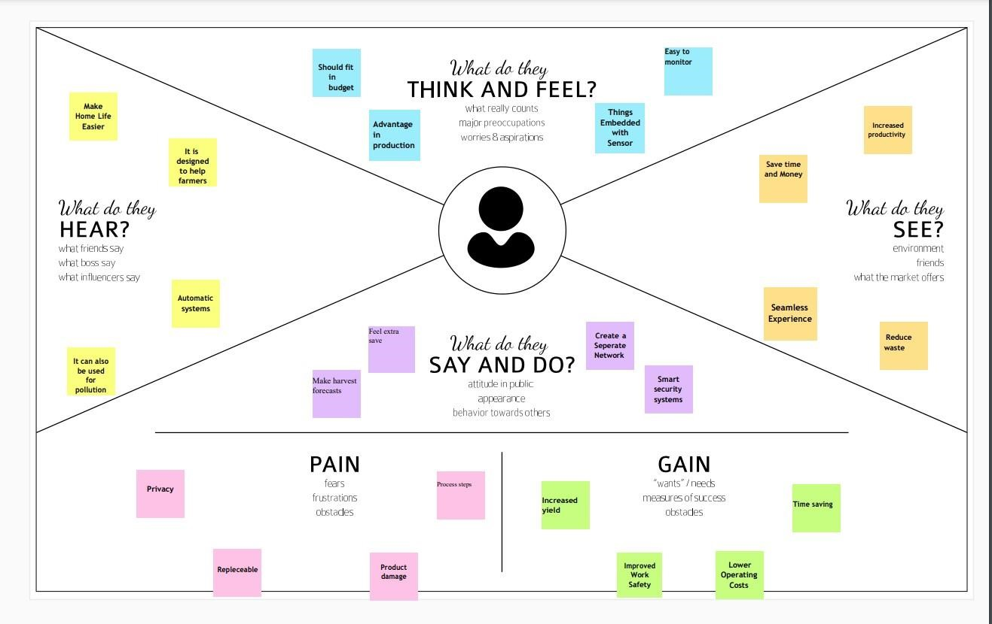

# 3.2 Ideation & Brain Storming

What do they think and feel?

As its name may imply, smart farming is the use of technology in animal agriculture, and it’s something that’s been around since the Industrial Revolution. The biggest difference between then and now, though? “Motorized devices are being replaced with IOT”.

What do they hear?

Smart farming is about using the new technologies which have arisen at the dawn of the Fourth Industrial Revolution in the areas of agriculture and cattle production to increase production quantity and quality, by making maximum use of resources and minimizing the environmental impact.

What do they see?

Smart farming is a management concept focused on providing the agricultural industry with the infrastructure to leverage advanced technology – including big data, the cloud and the internet of things (IoT) – for tracking, monitoring, automating and analyzing operations.

What do they say and do?

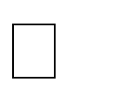The aim of this technology is to make the most of all the data collected by various tools, by converting them into real sources of information in order to then define ways of simplifying agricultural work. It also allows for accurate and predictive analysis of all situations that may affect the farms, such as weather conditions (temperature, humidity, etc.) and sanitary or economic situations, for example. This makes it easier to organize the supply of energy, water, livestock feed and fertilizer.

In its most advanced form, smart farming facilitates the exchange of information between different farms, creating a real network of connected farms accessible from a smartphone .

# 3.3 Proposed Solution

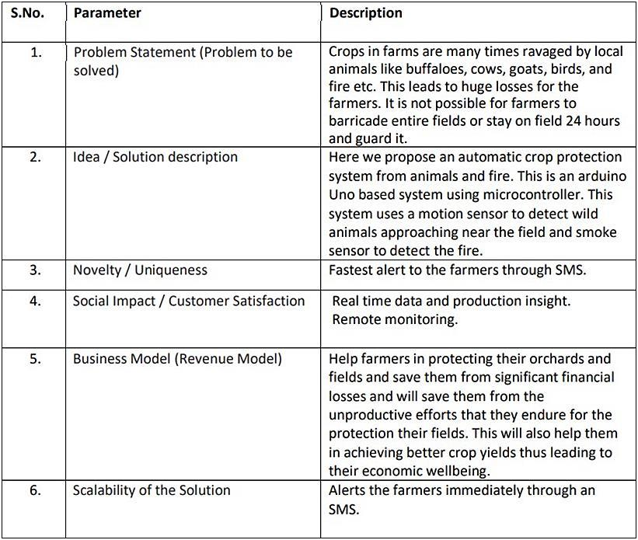

# 3.4 Problem Solution Fit

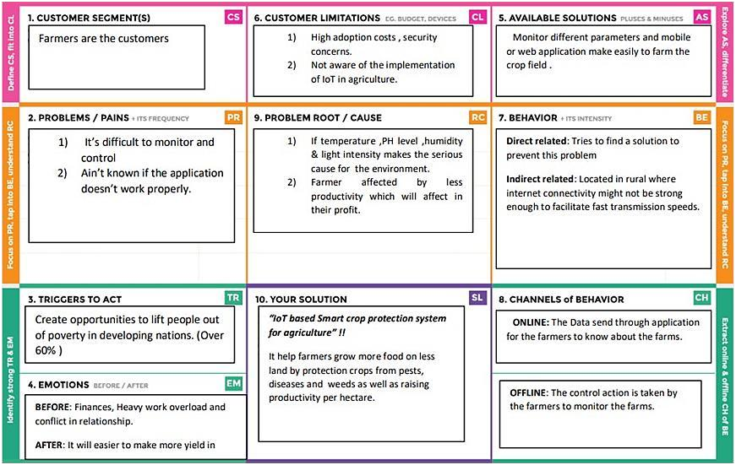

**4. REQUIREMENT ANALYSIS**:

# 4.1 Functional Requirements

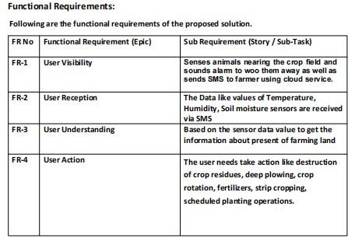

# 4.2 Non Functional Requirements

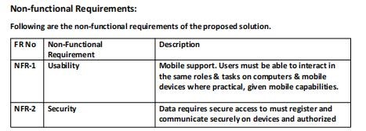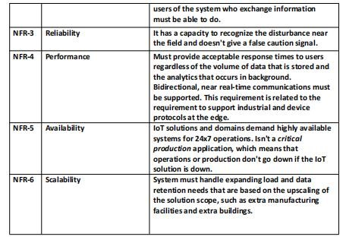

**5. PROJECT DESIGN**:

# 5.1 Data Flow Diagram

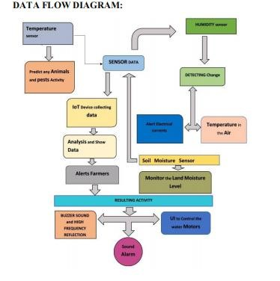

# 5.2 Solution & Technical Architecture

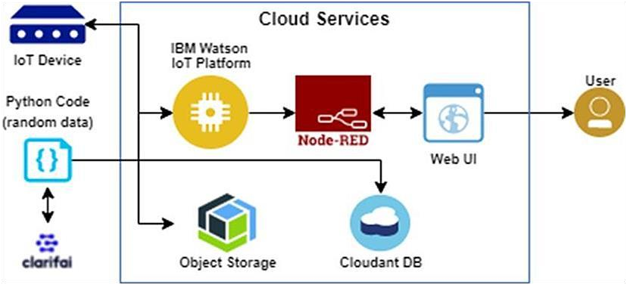

# 5.3 User Stories

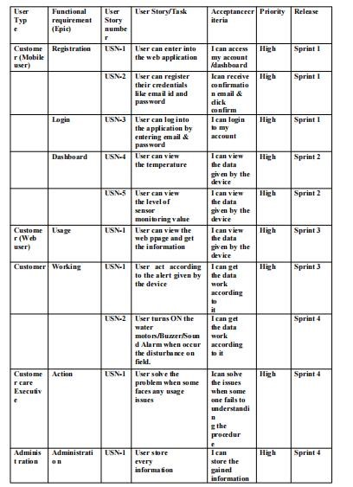

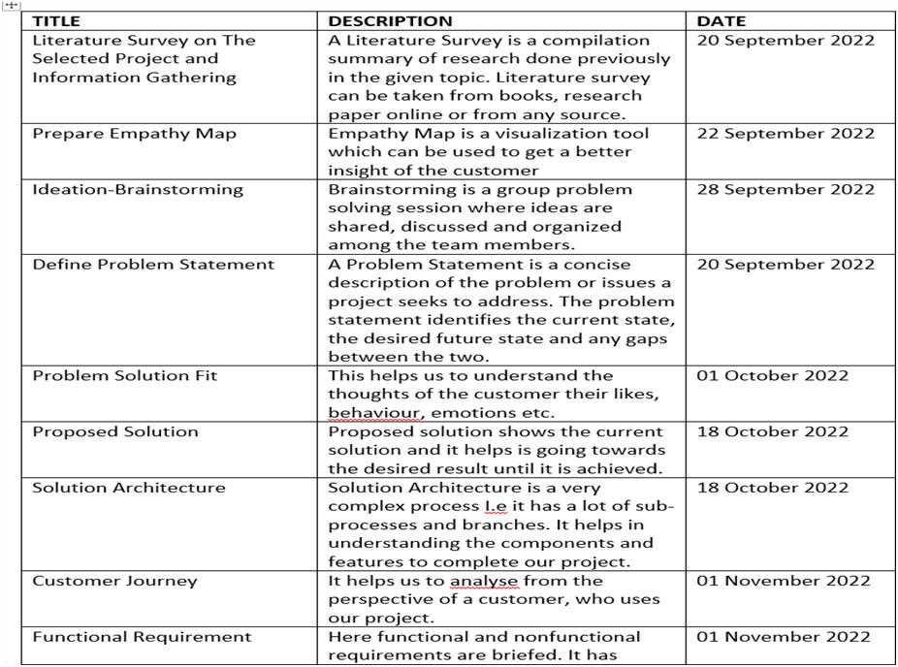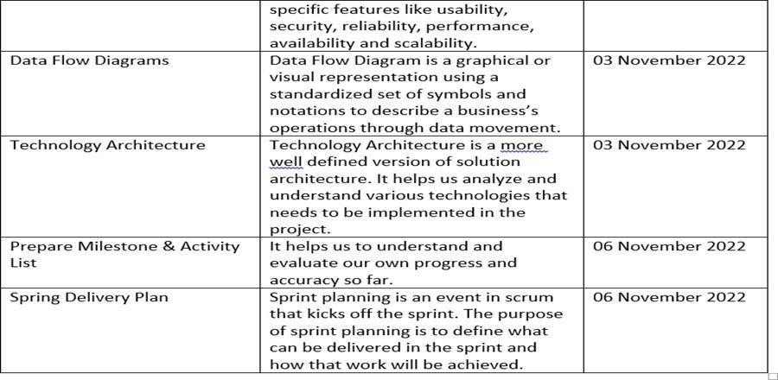

**6.**

**PROJECT**

**PLANNING&**

**SCHEDULING**

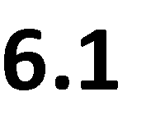

# 6.2 Sprint Delivery Schedule

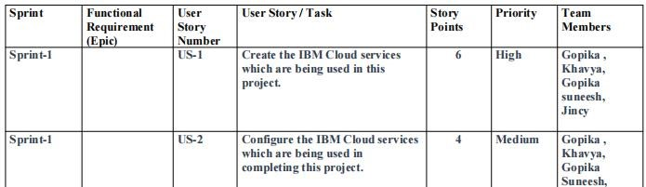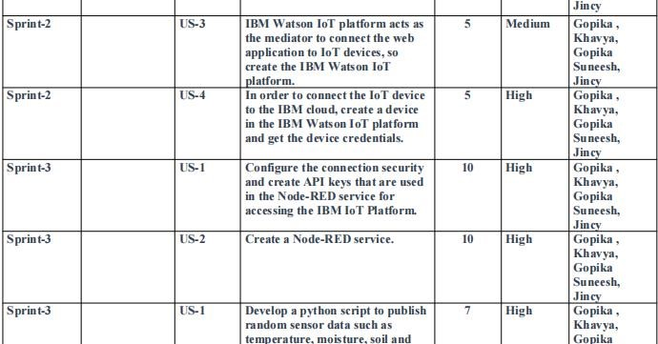

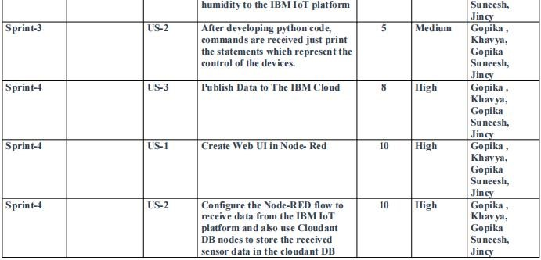

**7. CODING & SOLUTIONING:**

# 7.1 Feature 1

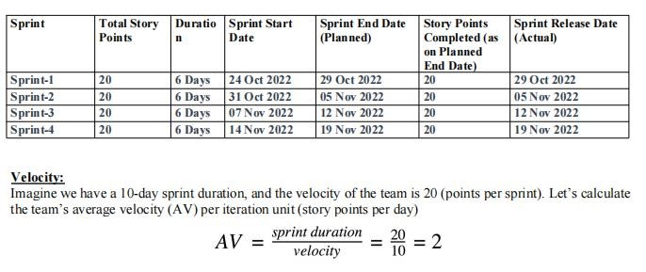

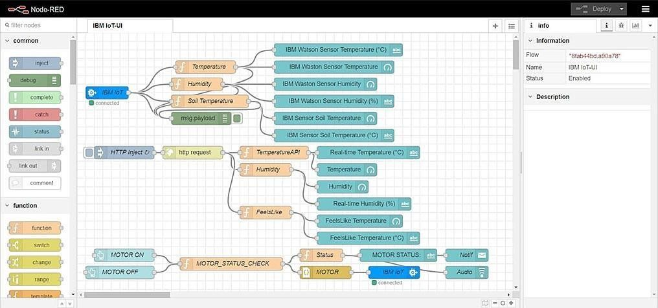

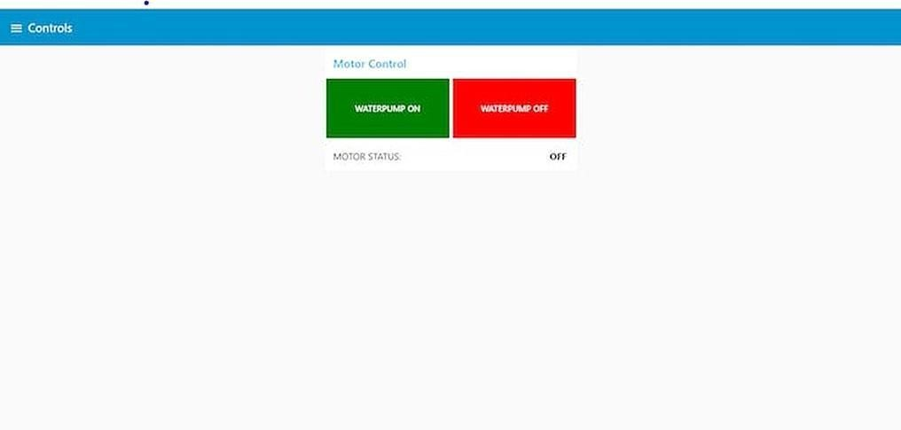

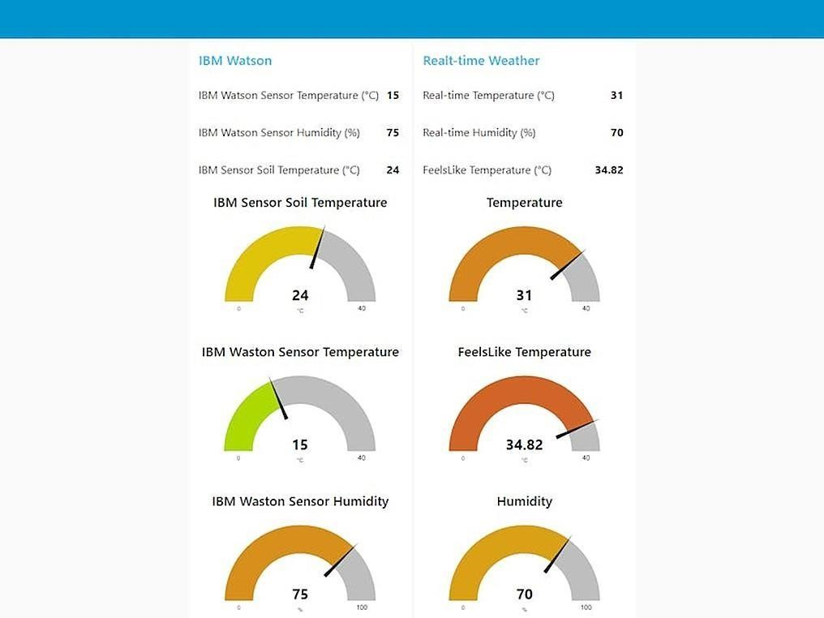

# 7.2 Feature 2

MIT APP inventor to design the APP

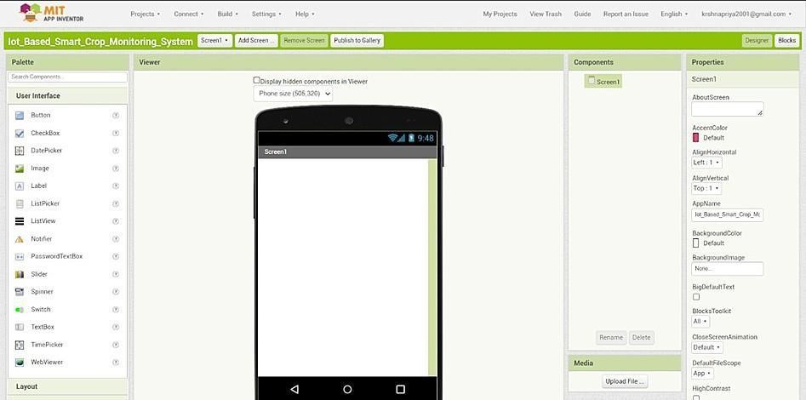

Customize the App interface to Display the Values

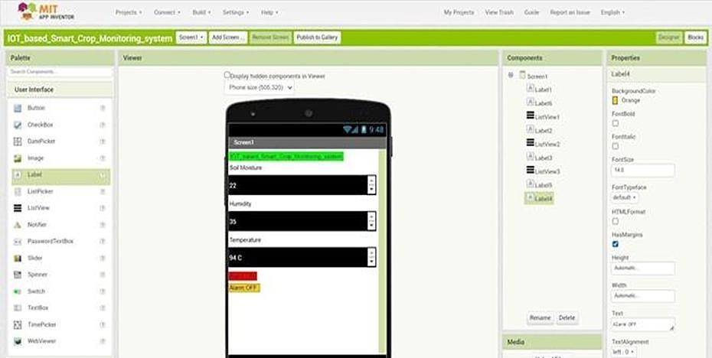

1. **TESTING**:

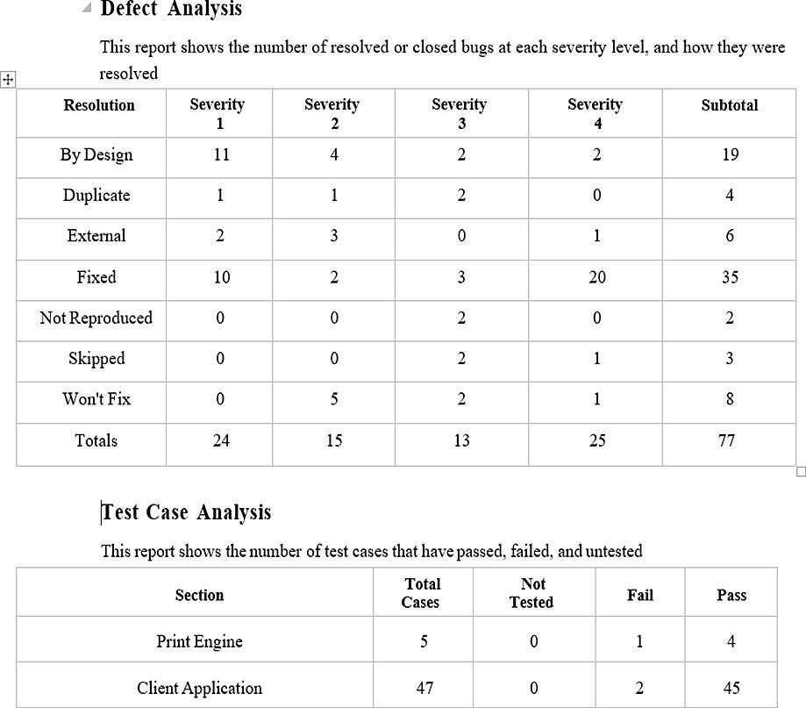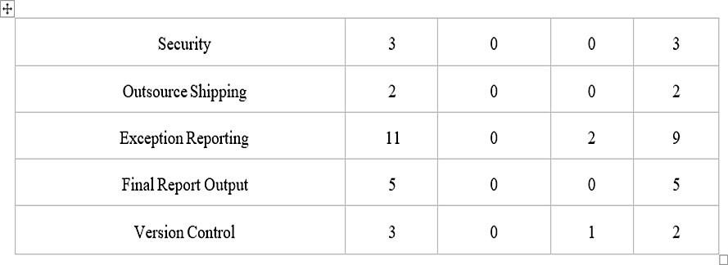

1. **RESULT:**

We have successfully built an IOT Based Smart Crop Protection System for Agriculture and integrated all the services using Node-RED.

1. **ADVANTAGES & DISADVANTAGES:**

# 10.1 Advantages

* All the data like climatic conditions and changes in them, soil or crop conditions everything can be easily monitored.
* Risk of crop damage can be lowered to a greater extent.
* Many difficult challenges can be avoided making the process automated and the quality of crops can be maintained.
* The process included in farming can be controlled using the web applications from anywhere, anytime.

# 10.2 Disadvantages

● Smart Crop Protection requires internet connectivity continuously, but rural parts cannot fulfill this requirement.

1. Any faults in the sensors can cause great loss in the agriculture, due to wrong records and the actions of automated processes.
2. IoT devices need much money to implement.
3. **CONCLUSION:**

IoT based smart Crop Monitoring System for Agriculture for Live Monitoring of Temperature and Soil Moisture and to control motor and light remotely has been proposed using Node Red and IBM Cloud Platform. The System has high efficiency and accuracy in fetching the live data of temperature and soil moisture. The IoT based smart farming System being proposed via this project will assist farmers in increasing the agriculture yield and take efficient care of food production as the System will always provide helping hand to farmers for getting accurate live feed of environmental temperature and soil moisture with more than 99% accurate results. Therefore, the project proposes a thought of consolidating the most recent innovation into the agrarian field to turn the customary techniques for water system to current strategies in this way making simple profitable and temperate trimming.

1. **FUTURE SCOPE**:

In future due to more demand of good and more farming in less time, for betterment of the crops and reducing the usage of extravagant resources like electricity and water IoT can be implemented in most of the places.

1. **APPENDIX**:

GITHUB LINK: https://github.com/IBM-EPBL/IBM-Project-40361-1660628649